You’re Invited
to a
Community Chat

“Open Streets & Riding to School”
This is a FREE event!
Blackburn Lake Visitor Centre, Wednesday 26th April


Come at about 7pm for a Sip'N'Nibble
with light refreshments.
Get to know your neighbours and then join a chat from about 7:30pm with Alison McCormack.
As the first female CEO in Bicycle Network's near-50-year history, Alison loves the idea of safe streets for children to play on and ride to school, and she's a fearless advocate for women feeling safe to ride too.
Bicycle Network’s Ride2School team works with schools and local authorities to facilitate special Open Streets days where the streets surrounding a school are dedicated to active transport only.
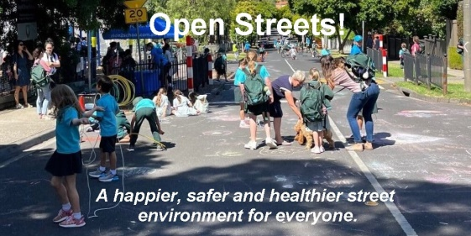
Open Streets days are carefully planned, with signage, traffic control and pre-event communication between schools, councils and residents.
Could this apply to your area?
Come and chat but please register for this event.

https://events.humanitix.com/community-chat-riding-to-school..
Or use the QR code
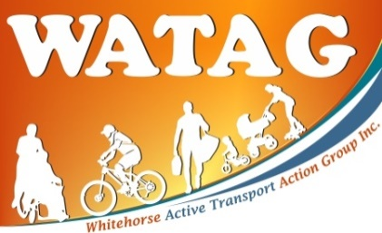

Whitehorse Active Transport
Action Group
www.watag.org

